***A Project Report***

***On***

***Travel Management System***

***SUBMITTED BY:***

*JIYA - CO21327*

*MEHAK – CO21343*

***Under the supervision of***

*Dr. Sarabjeet Singh*

***ACKNOWLEDGEMENTS***

*We thank Dr. Sarabjeet Singh who have been the great inspiration and who have provided sufficient background knowledge and understanding of this subject. We feel privileged to extend our deep sense of gratitude to our parents for their support and encouragement. We came to know about so many new things and we’re extremely grateful to them.*

***TRAVEL MANAGEMENT SYSTEM***

INTRODUCTION:

The **Travel Management System in C++** is a system that keeps travel data in a database and may add, delete, and amend user information in the database. The user can create new trips in the database and edit or delete existing trips as needed.

In this travel management system, we are going to create a code that will manage all the customers, cabs, bookings and the billing.

OBJECTIVES:

This system is developed to provide best travelling services to the customers and travel agents. This system also keeps a history of visited places of its users.

This system also helps to promote responsible and interesting tourism so that people can enjoy their holidays at their favourable places.

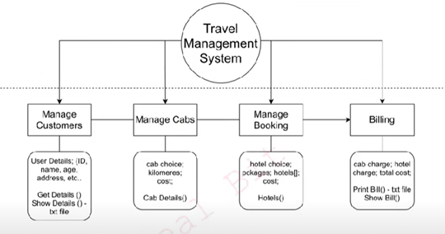

Modules:

* **Customers information:**

User details- ID, Name, Address, Age, etc.

* **Cabs Management:**

Cab choice, Kilometres, Cost

* **Booking Management:**

Hotel choice, Packages, Cost

* **Billing:**

Cab charge, Hotel charge, Total cost

